
Pump Analysis Performed by AcuSolve
Pump
Dr. Farzin Shakib
ACUSIM Software, Inc.
Mon Jun 28 13:49:24 2010

ACUSIM Software, Inc. 2685 Marine Way, Suite 1421, Mountain View, California 94043
Tel: (650) 988-9700 Fax: (650) 988-9770 info@acusim.com http://www.acusim.com

Contents

1 Background
Some background information.

2 Problem description
The geometry is given in Figure 1.

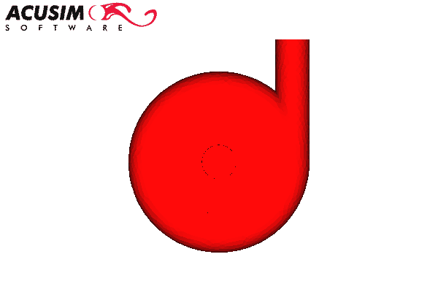
Figure 1: Geometry of the problem

2.1 Mesh
The geometry is given in Figure 2.

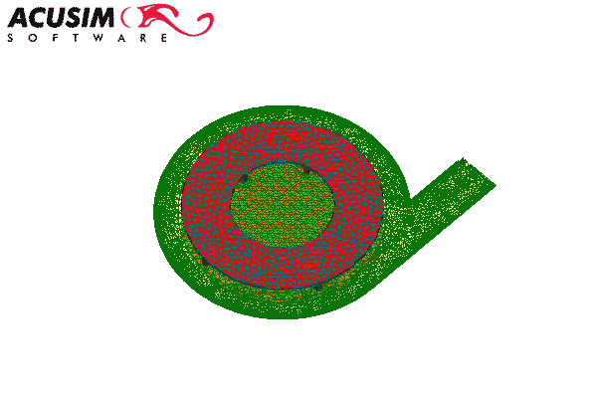
Figure 2: Geometry of the mesh

2.2 Solver Settings
Material model is given by:
Material Model for Fluid ’Water’
• Density Model
• Type = Constant
• Density = 1000.0
• Isothermal compressibility = 0.0
• Viscosity Model
• Type = Constant
• Viscosity = 0.001
• Multiplier function = None
Rotational speed is 10

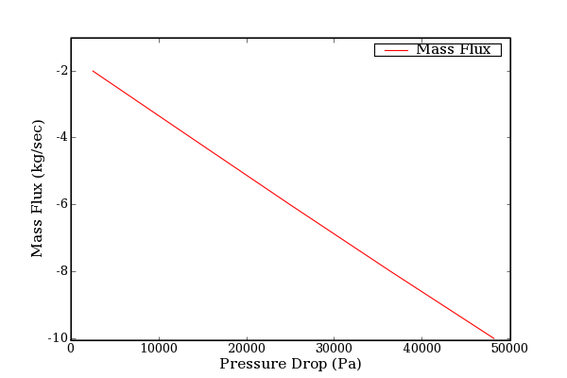
Figure 3: Fan performance

Pressure Drop (Pa) | Mass Flux (Kg/sec)
2506.57 | -2.00
13707.15 | -4.00
24949.46 | -6.00
36406.80 | -8.00
48129.20 | -10.00

Table 1: Fan performance
The fan performance curve is given in Figure 3 and Table 1

3 Results
The results are given in the following figures.
The pressure distribution are shown in the following figures.

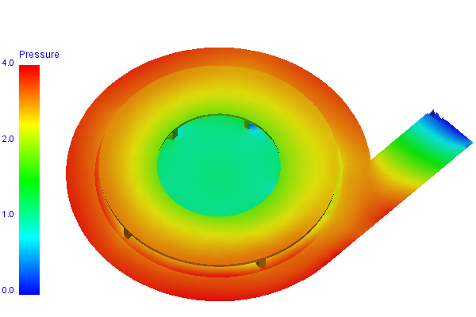 | 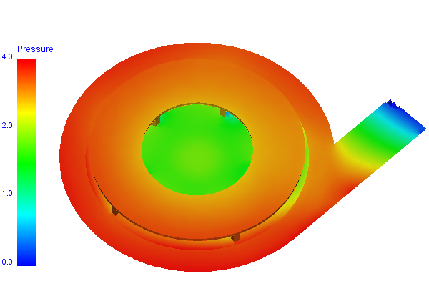
a. mass flux = -2 | b. mass flux = -4
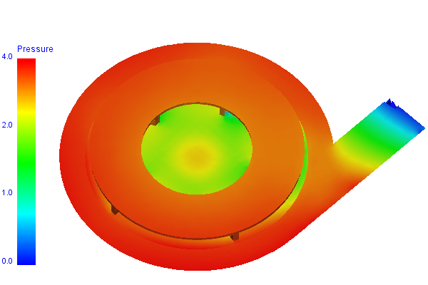 | 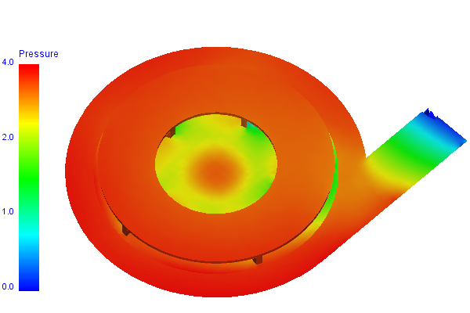
c. mass flux = -6 | d. mass flux = -8
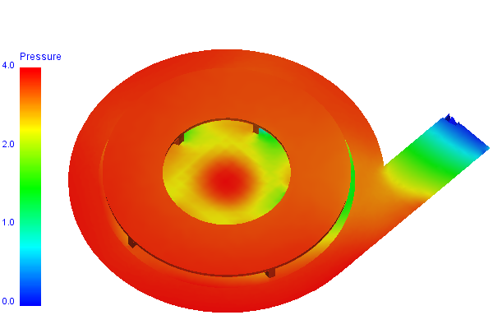
e. mass flux = -10

Figure 4: Pressure contour on center plane

The velocity distribution are shown in the following figures.

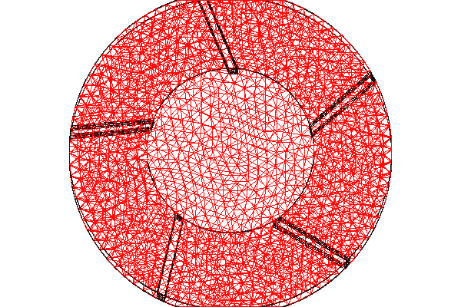
a. mass flux = -2 | b. mass flux = -4
c. mass flux = -6 | d. mass flux = -8
e. mass flux = -10

Figure 5: Velocity vector on center plane

Several samples of clipping are shown in the following figures.

 | 
Fully-Transparent ’Up’ Clip Plane | 90%-Transparent ’Down’ Clip Plane
 | 
Fully-Transparent ’Max’ Clip Box | 90%-Transparent ’Max’ Clip Box
 | 
Fully-Transparent ’Min’ Clip Box | 90%-Transparent [Prep by a Clip-Plane] ’Min’ Clip Box

Figure 6: Clipping Samples

4 Conclusions
Some conclusion goes here

